**Lab: 01**

Advanced Object-Oriented Programming

PROG2200

Date: September 23, 2022

By: Diana Hakim - W0420915

# General

## Demonstrate that you have made multiple commits as you went through the Learning C# course: at least 5.

<https://github.com/Diana-W0420915/PROG2200>

Figure

## Show that you have the right README and .gitignore for Visual Studio. Update the Readme file to state your name and your student number. Also, arrange your project according to the structure outlined above.

<https://github.com/Diana-W0420915/PROG2200>

|  |  |
| --- | --- |
| Figure README.md with my name and student number written inside | Figure .gitignore for Visual Studio |

## Module 1: Basics

## Take the Challenge 1 (Multiple Choice) and add two more questions of your choices to it.

Figure

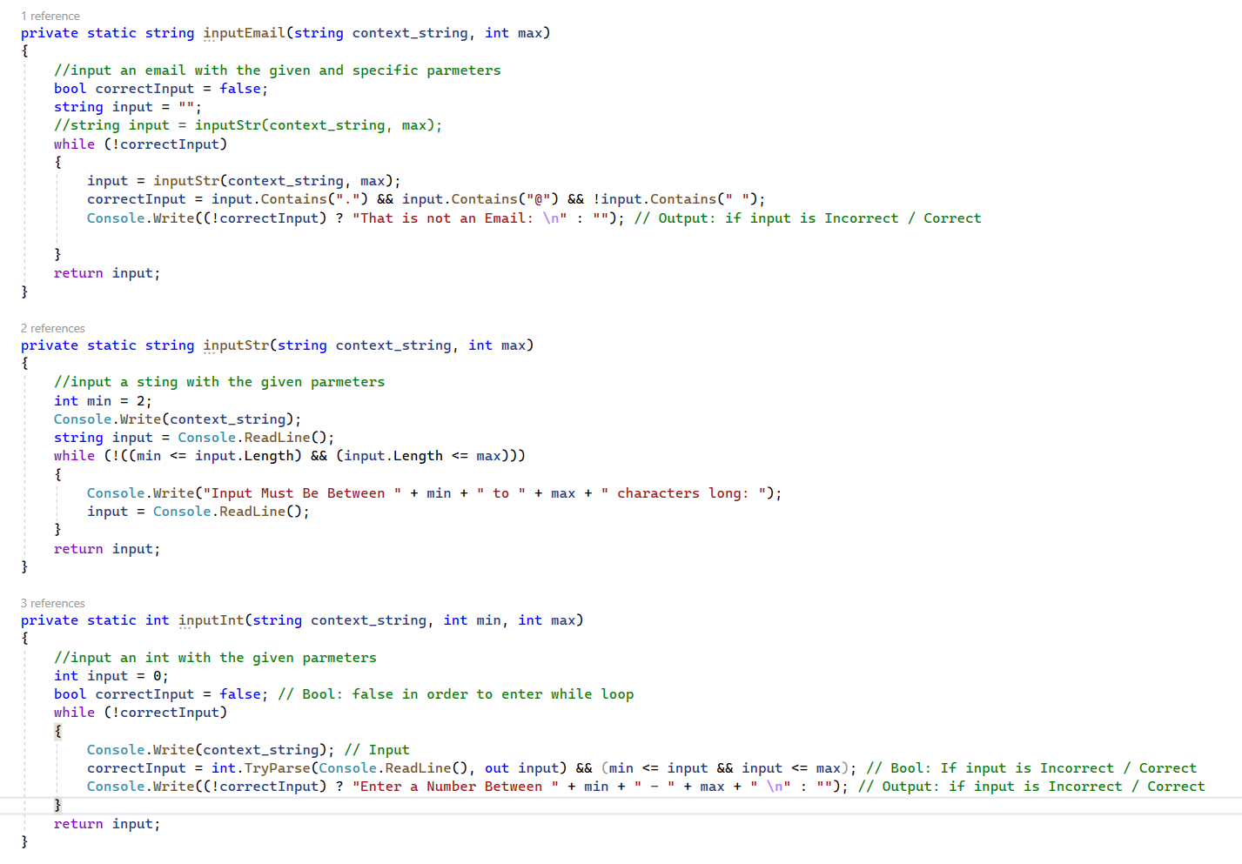

## Alter Challenge 2 (Passcode) so that the user can change the password after authenticating.

Question: Is an else...if the best option for checking the secret? Simplify the code to not use

else…if as described.

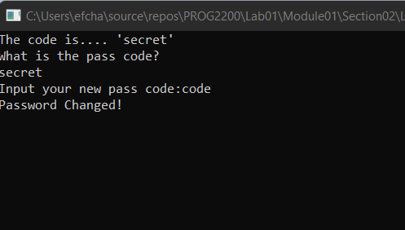

### Video

## Change Challenge 3 (Loop Counting) to be only 2 loops (instead of 3) with a conditional

## In Challenge 4 (Student Manager) there are two arrays: studentNames and studentGrades. How could you replace these with a single two-dimensional array?

I.e., Each row in the main array is

itself an array of two elements: one for name, one for grade.

Hint: A 2D array is declared in C# as: var array = new string[<size>,<size>].

You will need to remove parsing of ints for this exercise and store everything as a string as 2D

arrays are of a specific type.

# Module 2: OOP in C#

## Challenge 5

Change the Survey console app to be a full Zodiac Calculator. Requirements: Also take the day of the month as an input. Use a switch statement to calculate what star sign matches the month and date. You should validate that the user entered a number for month and date.

# Module 3: Exception Handling & Debugging